Stephen Fedewa, Travis Simmons, David Forystek

Team: xX_nohaxjustFoodQuest_Xx

Github repository: <https://github.com/TheNerdyGinger/SI-206-Final-Project>

Presentation: <https://docs.google.com/presentation/d/1LI6HW95cODhf26zRZhB2vRyzmFVePZMW0FBYBj2CMgQ/edit#slide=id.p>

SI 206 Final Project Report: Foodquest

1. The Goals for your project

* We wanted to take a recipe and find the healthiest brands from around the world to use as ingredients. This is an ideal scenario where we can easily get any food item we want regardless of location. (Maybe teleportation has already been invented).

1. The goals that were achieved

* Could take the first 10 brands from a search query and find the healthiest option among them.
* Found specific brand options for most ingredients we searched for.

1. The problems that you faced

* We found that we couldn’t search for ingredients by product name. For example, if a recipe called for “black pepper”, searching by product could come up with “Black Pepper Potato Chips.” We had to switch to searching by category.
* Searching by category worked most of the time. Most basic ingredients had categories associated with them. However, certain ones did not. This wasn’t helped when recipes had weird naming conventions such as “sugar (granulated).” To solve this, we had to come up with some failsafe methods in case we didn’t find any specific brands.

1. Your file that contains the calculations from the data in the database

* Foodquest.db database, recipe_output.txt for output.

1. The visualizations you created (screenshots)

Map of the most common countries to show up in our brand data. Made using the mapquest API

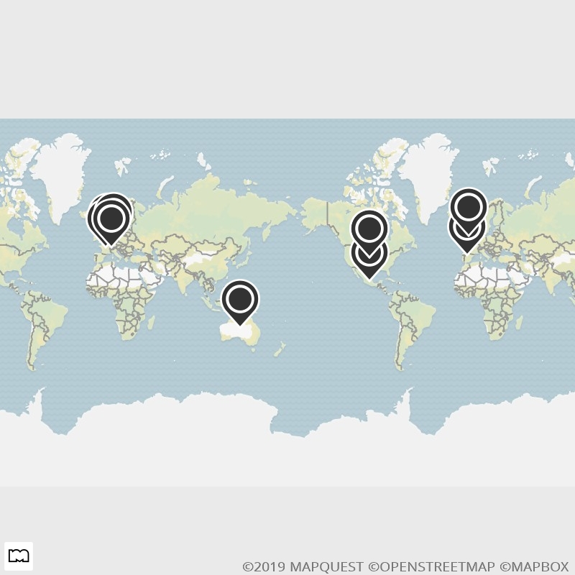

Pie chart showing the 10 most common countries brands were sold in

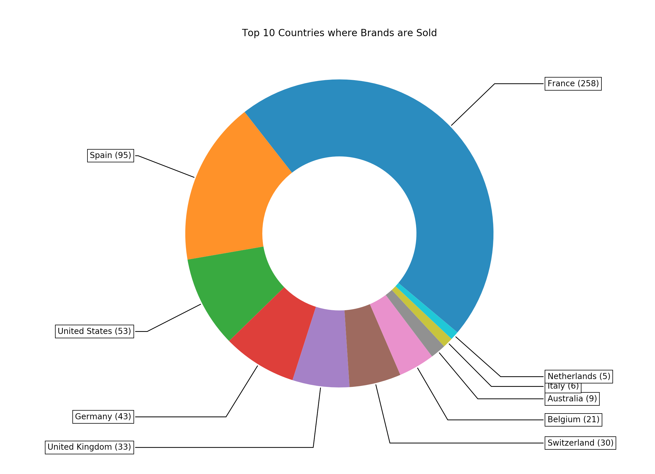

Word Cloud showing how common each ingredient was in each recipe. The larger the text, the more recipes this ingredient showed up in. Made using Plotly

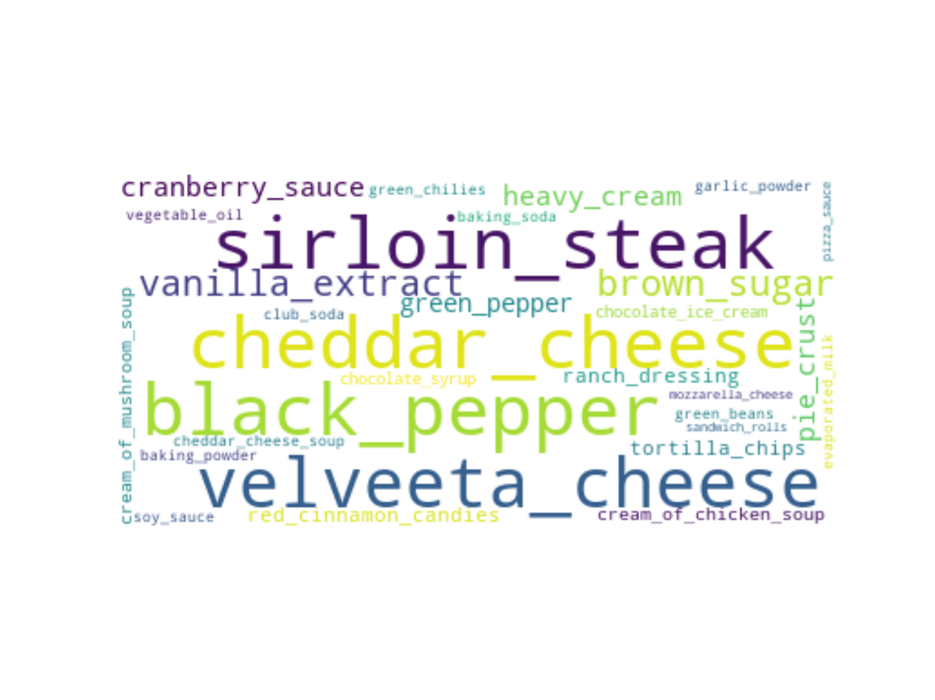

Pie chart showing the number of ingredients in each recipe. Made using Matplotlib

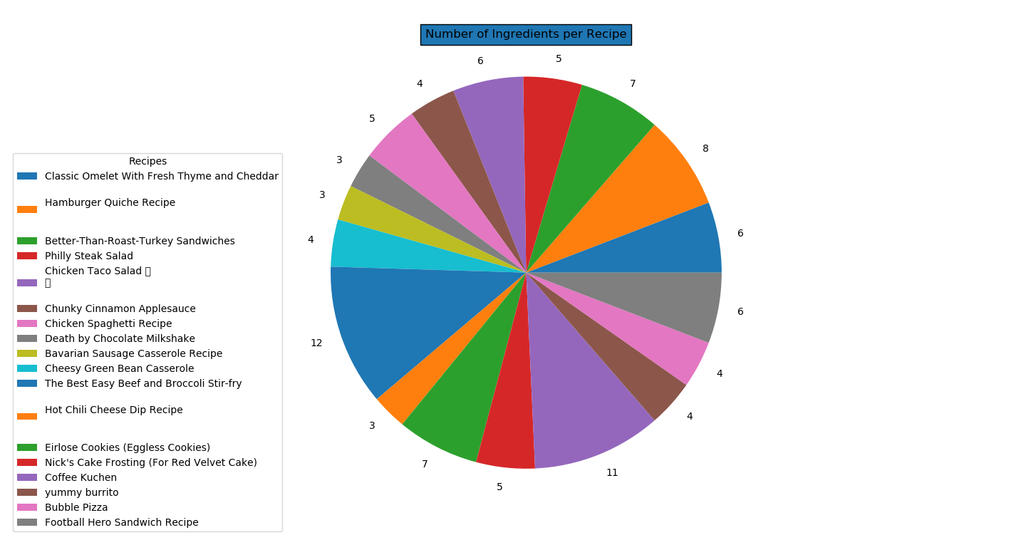

Bar graph showing the average nutrition score for each recipe. Made using MatPlotLib

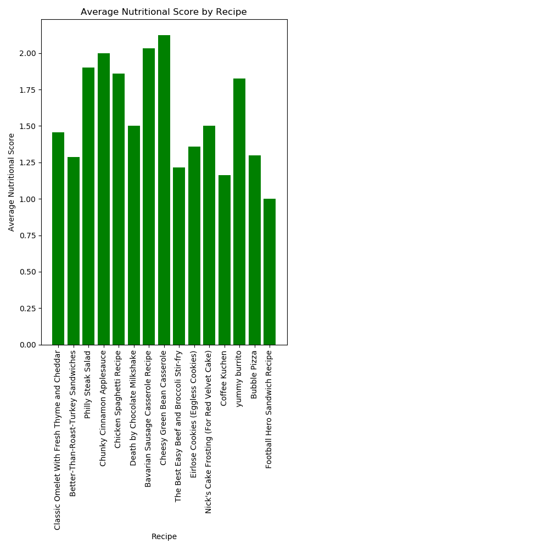

Bar graph showing all of the brands for the “pasta” ingredient and their scores after breaking ties with their distances from Ann Arbor. Made with Matplotlib

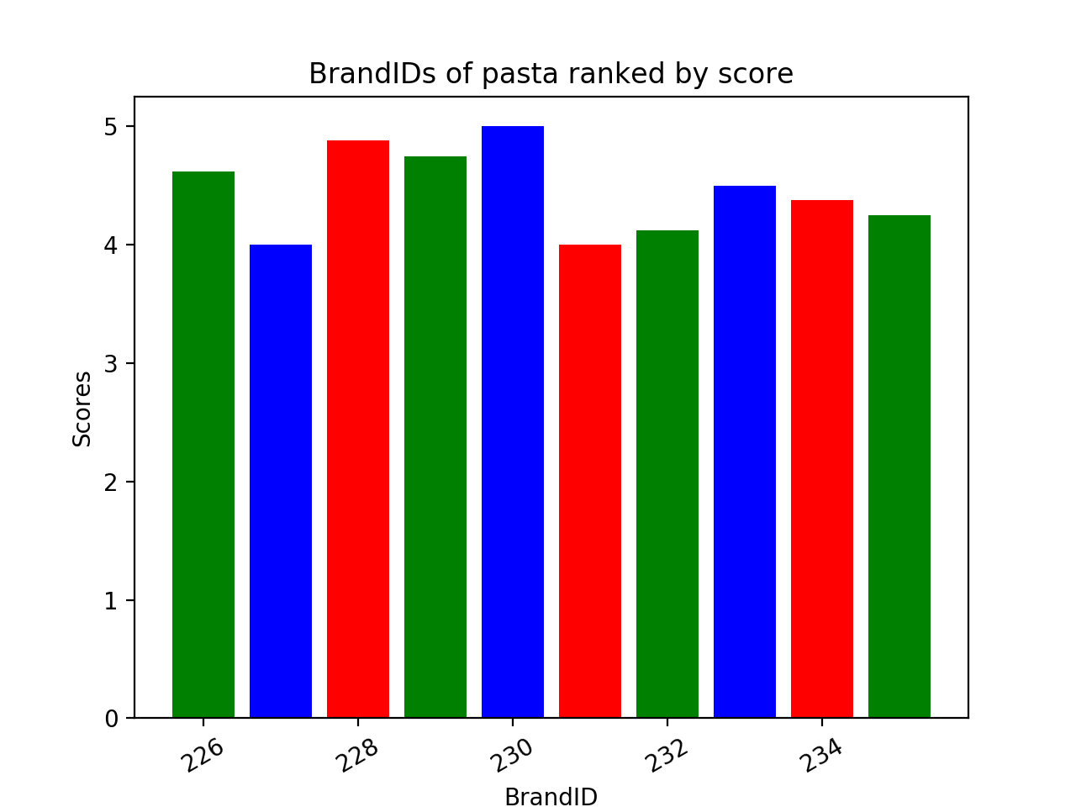

1. Instructions for running your code
   1. Install the following libraries:

* Geopy <https://geopy.readthedocs.io/en/stable/#installation>
* Inflect <https://pypi.org/project/inflect/>
* Plotly <https://plot.ly/python/getting-started/>
  1. If starting from the turned-in zip file, delete foodquest.db or erase all records from it. Open off_bookmark.txt, erase all text, write ‘0’, and save the file.
  2. Open mapquest.py and keep running it until it prints “No more countries to input” (Run about 12 times)
  3. Run recipe_puppy.py until it prints “NO NEW RECIPES” (About 18 times)
  4. Run off.py until it prints “No more ingredients to check” (About 66 times)
  5. Run combine_data.py until it prints “No more ingredients to check” (About 66 times)
  6. Run recipes_and_best_brands until it prints “No more recipes to check” (About 18 times)
  7. Run visualizations.py once
  8. View the text output in recipe_output.txt and the visualization files.

1. Documentation for each function that you wrote. Includes the input and output for each function

**Mapquest.py:**

def setUpDatabase(db_name):

* Takes in a db_name as a string and sets up cur and conn with the given database name. Returns cur and conn

def get_countries(filename):

* Takes in a CSV final with a list of countries as input, returns a python list of countries as output.

def get_mapquest(country_list, cur, conn, start):

* Takes in the country list from get_countries, database cursor, database connection, and the start variable as input.
* Calls mapquest geocode API to receive latitude and longitude for each country in country_list and stores in the database.
* Start variable used to limit commits to the database to 20 per run of code.
* Does not return anything.

def get_distance(cur, conn, start):

* Takes in the database cursor, database connection, and start variable as input
* Uses mapquest geocode API to fetch latitude and longitude of Ann Arbor, MI
* Fetches latitude and longitude for every country in country_list and uses geopy library to calculate distance. Start variable used to fetch 20 entries from the database at a time.
* Commits distance calculation to database at 20 entries at a time.
* Does not return anything.

def main():

* sets database to “foodquest.db”, sets database cursor and database connection
* Sets up the Countries, Lat_lng, and Distances tables
* calls country_list, get_mapquest, and get_distance
* Selects countries from database at 20 per run of code

**Recipepuppy.py**

def get_data(ingredients, recipe):

* Requests data from the RecipePuppy API and returns a json dictionary of the recipes and ingredients

def read_file(filename):

* Reads the file that contains multiple parameters for the get_data function and returns each line in the file

def create_tuples(filename):

* Returns a list of tuples with the first element being the recipe name and the second element being the list of ingredients for the recipe

def create_database(filename):

* Takes the data taken by create_tuples and creates tables in the database that contain the following:
  + A table with recipes and unique recipe IDs
  + A table with ingredients and unique ingredients IDs
  + A table matching each unique ingredient ID with a recipe ID

**Off.py**

def setUpDatabase(db_name):

* Takes in a db_name as a string and sets up cur and conn with the given database name. Returns cur and conn

def format_ingredient_name(ing):

* Takes in an ingredient name as a string, converts it to lowercase, replaces spaces with hyphens, and uses inflect library to pluralize it. Returns the newly formatted ing.

def format_ingredient_no_plural(ing):

* Takes in an ingredient name as a string, converts it to lowercase, and replaces spaces with hyphens. Returns the newly formatted ing.

def format_countries(countries, cur, conn):

* Takes in a list of country names, and the cur and conn of the database
* For each country in country names:
  + If already in the database, get its country ID and append it to a list of country ids called c_ids.
  + Else (if not found), make a mapquest request just like mapquest.py to add that country and its necessary data to the database. Appends the newly inserted country_id to c_ids.
* Return c_ids

def insert_into_tables(cur, conn, product_name, nutriscore, countries, ingredient_id)

* Takes in the database’s cur and conn, a product name, it’s nutrition score, a list of countries where the product is sold, and its ingredient id
* Determines a brand_id and inserts brand_id, product_name, ingredient_id, and nutriscore into Brands_and_scores table
* For each c_id in countries:
  + Insert brand_id and c_id into Brand_countries_sold table

def insert_if_not_found(cur, conn, ing_id):

* Takes in the cur and conn of the database and an ingredient id.
* This function is used if a specific brand could not be found for a given ingredient.
* Determines a brand_id and inserts brand_id, the generic ingredient name, and a nutriscore of 0 into Brands_and_scores table
* Inserts brand_id and a country id of 225 (United States) into Brand_countries_sold table

def parse_json(data, cur, conn, ingredient_id):

* Takes in a python list of json data on potential brands, the database cur and conn, and an ingredient id
* Loops until we’ve inserted 10 brands into the database, or until we’ve checked every product in the json data.
* For each brand:
  + Find nutriscore
  + If nutriscore not found
    - Find nova_group
    - If nova_group not found
      * Restart loop, move to the next brand
  + Else, convert nova_group to a proper nutrition score
  + If nutriscore is a string (character), convert it to its corresponding integer score
  + Obtain product name and list of countries. Convert countries to country_ids by calling format_countries(countries, cur, conn)
  + Call insert_into_tables(cur, conn, product_name, nutriscore, countries, ingredient_id)
* If no brands were inserted, call insert_if_not_found(cur, conn, ingredient_id)

def request_url(cur, conn):

* Takes in the cur and conn of the database.
* Creates Brands_and_scores and Brand_countries_sold tables if they don’t exist
* Uses a number from off_bookmark.txt to determine where to begin inserting into the tables. (integer variable pos) And to check if we’ve already inserted everything we need to.
* Selects one ingredient to look at and calls format_ingredient_name to pluralize it.
* Tries to make a request to the Open Food Facts API, searching by category using the pluralized ingredient name. Loads the result into a list called data. Prints “error reading from url” and makes data an empty list if there is an exception.
* If no products are found:
  + Tries to make another request, this time with a non-pluralized version of the ingredient name. Loads response into list data2 Prints “error reading from url” and makes data2 an empty list if there is an exception.
  + If still no products found: call insert_if_not_found(cur, conn, pos)
  + Else, call parse_json(data2, cur, conn, pos)
* Else, call parse_json(data, cur, conn, pos)
* Closes off_bookmark.txt, and reopens it to write pos+1 into it. Closes bookmark.txt

def main():

* Calls setUpDatabase(“foodquest.db”) which returns cur and conn variables
* Calls request_url(cur,conn) to begin collecting data.

**Combine_data.py**

def setUpDatabase(db_name):

* Takes in a db_name as a string and sets up cur and conn with the given database

def get_shortest_distance(tup, cur, distances):

* Takes in a tuple containing a brand_id, the database cur, and a list of distances from Ann Arbor for a few countries
* Grabs which countries the brand with the passed brand_id is sold in, and uses the distances list to determine those countries’ distance from ann arbor.
* Loops through the returned list of countries to find which one has the shortest distance.
* Returns the float value of the shortest distance.

def insert_combined_score(start, brands_and_scores, cur, conn):

* Takes in an index of insertion representing an ingredient id, a list of brands and their combined scores, and the cur and conn of the database
* for b in brands_and_scores:
  + Insert (start, b[0], b[1]) into Combined_score table

def insert_best_brand(start, brand, cur, conn):

* Takes in an index of insertion representing an ingredient id, a brand id, and the cur and conn of the database.
* Inserts (start,brand) into Best_brands table

def combine(cur, conn):

* Takes in the database cur and conn.
* Creates Combined_score and Best_brands tables if they don’t exist.
* Determines the position to start inserting and checks if we’ve already checked all of the data.
* Grabs all the brands and nutrition scores for one ingredient and saves them into a list of tuples called brands_and_scores
* Grabs all of the unique ids for countries sold for all the brands in brands_and_scores. (If multiple brands are sold in france, france will still show up once in the list)
* Makes a dictionary of distances for all of the countries in countries list.
* Sorts brands_and_scores by nutrition score in descending order, and determines the highest score.
* For every brand that ties for the highest score:
  + Call get_shortest_distance to find the closest country the brand is sold in. (These will be used as tie breakers)
  + Adds this shortest distance as a 3rd element for those tuples.
* Sort tied brands by distance
* Determines subtractor variable = 1/(number of tied brands)
* Count = 0
* For each tied brand:
  + Subtract (count * subtractor) from score (tuple[1])
* Call insert_combined_score(start, brands_and_scores, cur, conn) and insert_best_brand(start, brands_and_scores[0][0], cur, conn)

def main():

* Calls setUpDatabase to get cur and conn, then calls combine(cur, conn)

**Recipes_with_best_brands.py**

def setUpDatabase(db_name):

* Takes in a db_name as a string and sets up cur and conn with the given database

def main():

* Calls setUpDatabase to get cur and conn.
* Creates Recipes_and_best_brands table if it doesn’t exist
* Determines the point to ‘start’ inserting and checks if we’ve already run through each recipe.
* Grabs all of the ingredients for one recipe from the database. Saves them in list ‘ings’
* For i in ings:
  + Find the best brand for ingredient i from the best_brands table
  + Insert (start, best_brand) into Recipes_and_best_brands table.

**Recipe_output.py:**

def setUpDatabase(db_name):

* Takes in a db_name as a string and sets up cur and conn with the given database

def join_databases(cur, conn, filename):

* Takes in the database cur and conn and a file name to output to.
* Performs a join on Recipes, Brands_and_scores, and Recipes_and_best_brands tables to create a list of tuples containing recipe names and best_brand names instead of ingredients. Saves the data in output_table list variable
* Opens a file with the given filename to write to.
* Loops over output_table to output the data to a text file in the following format:
  + *Recipe_name1: brand1, brand2, … \n*
  + *Recipe_name2: brand1, brand2, … \n*
* Closes the output file and returns output_table

def main():

* Calls setUpDatabase to get cur and conn.
* Calls join_databases(cur, conn, "recipe_output.txt")

**Visualizations.py**

def setUpDatabase(db_name):

* Takes in a db_name as a string and sets up cur and conn with the given database name. Returns cur and conn

def grab_wordcloud_data(cur, conn):

* Takes database cursor and database connection as input.
* Fetches ingredients from database
* Adds all the ingredients to a string, returns string of ingredients as output

def word_cloud(word_string):

* Takes the word string from grab_wordcloud_data as input
* Uses plotly to generate word cloud
* Does not return anything

def grab_pie_data(cur, conn):

* Takes database cursor and database connection as input
* Fetches countries from database and appends to list
* Returns list of countries as output

def pie_graph(country_list):

* Takes in list of countries from grab_pie_data as input
* Sorts countries by number of brands sold
* Generates pie graph
* returns list of sorted countries as output

def grab_staticmap_data(cur, conn, country_list):

* Takes in database cursor, database connection, sorted country list returned by pie_graph as input
* Fetches coordinates of all those countries from database and appends to list
* Returns list of coordinates as output

def staticmap(coord_list):

* Takes in list of coordinates from grab_staticmap_data as input
* Calls mapquest static map API to produce a static map of the top countries where brands are sold marked on the map
* Uses webbrowser module to open static map in web browser
* Does not return anything

def grab_barchart_data(cur, conn):

* Takes in database cursor and database connection as input
* Fetches ingredients and recipes from database
* Calculates average nutrition score for each recipe
* Produces bar graphs with ingredient/recipe on the x-axis and nutrition/average score on y-axis
* returns dictionaries as ingredient_score_dict and recipe_score_dict

def barchart(ingredient_score_dict, recipe_score_dict):

* Takes ingredient_score_dict and recipe_score_dict from grab_barchart_data as input
* Produces bar graphs with ingredient/recipe on the x-axis and nutrition/average score on y-axis
* Does not return anything

def get_data(dbname, command):

* Sets up connection to database
* Returns data from database

def plot_bar_graph():

* Plots a bar graph containing the nutrition scores for all brands of pasta sorted by BrandID

def plot_pie_chart():

* Plots a pie chart showing the number of ingredients for each recipe in the database

def main():

* Calls all of the previous functions to produce visualizations

1. Document all resources you used in the following format

Date: Issue Description: Location of Resource: Result (Did it solve the issue?):

|  |  |  |  |
| --- | --- | --- | --- |
| DATE | ISSUE | RESOURCE | RESULT |
| 12/11/19 | Joining 3 tables at once | <https://www.dofactory.com/sql/join> | solved |
| ~12/1/19 | Selecting max id from table. | <https://stackoverflow.com/questions/7604893/how-do-i-select-an-entire-row-which-has-the-largest-id-in-the-table> | solved |
| 12/15/19 | Capitalizing every word in a string. | <https://stackoverflow.com/questions/1549641/how-to-capitalize-the-first-letter-of-each-word-in-a-string> | solved |
| 12/15/19 | Adding a legend to a pie chart | <https://stackoverflow.com/questions/19852215/how-to-add-a-legend-to-matplotlib-pie-chart> | solved |
| 12/14/19 | Opening a url in python | https://stackoverflow.com/questions/4302027/how-to-open-a-url-in-python | solved |
| 12/14/19 | Creating Donut Pie Graph | https://matplotlib.org/3.1.1/gallery/pie_and_polar_charts/pie_and_donut_labels.html#sphx-glr-gallery-pie-and-polar-charts-pie-and-donut-labels-py | solved |
| 12/14/19 | Generating Word Cloud | <https://amueller.github.io/word_cloud/auto_examples/simple.html> | solved |
| 12/14/19 | Fixing Overlapping labels in matplotlib | https://stackoverflow.com/questions/26700598/matplotlib-showing-x-tick-labels-overlapping-despite-best-efforts | solved |
| 12/8/19 | Using geopy distance function | https://geopy.readthedocs.io/en/stable/#module-geopy.distance | solved |
| 12/14/19 | Using Mapquest Static Map | https://developer.mapquest.com/documentation/static-map-api/v5/getting-started/ | solved |
| 12/1/19 | Pluralizing words with inflect | <https://pypi.org/project/inflect/> | solved |